QUESTION 1 –
ANSWER 1 - Multiple Linear Regression is the most suitable model for this setting because it is simple, transparent, and easy to explain to non-technical business stakeholders. It clearly shows how factors like price, promotions, and advertising spend affect weekly sales.
The model is also well suited for budget allocation decisions, as it helps managers understand which variables have the biggest impact on sales and estimate returns from increased spending.
Since the model can be updated only once per quarter, linear regression is a good choice because it is stable and not overly sensitive to short-term fluctuations.
Compared to other parametric models such as ARIMA, Ridge/Lasso, or Logistic Regression, it offers the best balance between interpretability, business usefulness, and reliability.
ANSWER 2- Since the model is meant for business people, the goal is not to build the most complex or most accurate model. The goal is to build a model that people can understand, trust, and actually use. That’s why I keep things simple.
If we add too many variables, the model may become slightly more accurate, but it becomes confusing and harder to explain.
I also avoid strong regularization. While it can improve accuracy, it makes the results harder to interpret. For budget decisions, decision-makers need clear and stable numbers, not perfect accuracy.
A simpler model that everyone understands is more valuable than a complex model that performs slightly better but isn’t trusted.
ANSWER 3 - One diagnostic step I would prioritise is checking the stability of key model coefficients over time. Since the model is used for budget allocation, it is important that the impact of variables such as price and advertising spend remains consistent. Stable coefficients help managers rely on the model while making financial decisions.
One diagnostic step I would deprioritise is excessive focus on minimising error metrics such as MSE or RMSE. Small improvements in prediction accuracy do not significantly affect budget decisions and may increase model complexity.
A stable and interpretable model is more useful for decision-making than a highly optimised model with marginally better accuracy.
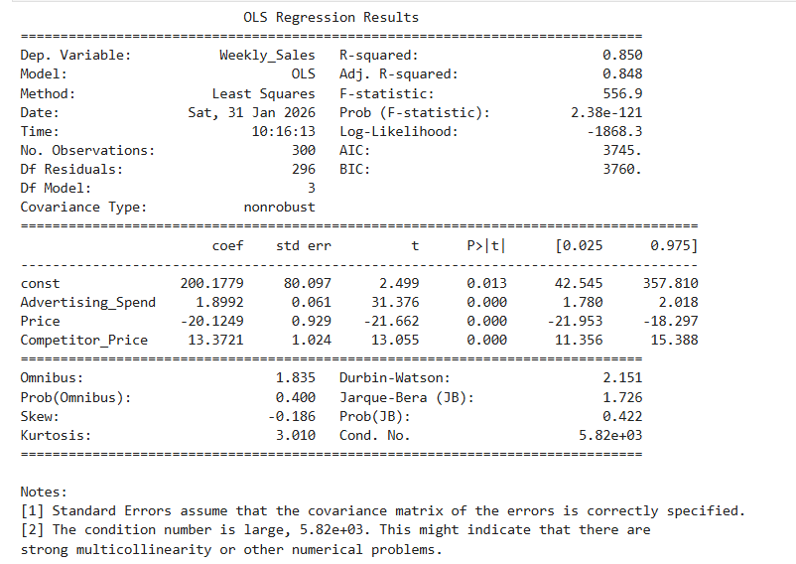
Question 2 -
Answer 1- Non-Parametric Algorithm: Decision Tree
I would choose - Decision Tree because it does not assume any predefined mathematical form (like linear, normal, or logistic).
Instead, it learns decision rules directly from data by repeatedly splitting it into smaller groups.
ANSWER 2 - a
- Past patterns represent valid decision logic
The tree assumes that historical relationships between advertising spend, price, competitor price, and sales will continue in the future.
- Sharp thresholds are meaningful
It assumes that exact cut-offs (for example, price above or below a value) create real differences in outcomes, even though real markets usually change smoothly.
- Greedy splits lead to good decisions
The tree assumes that choosing the best split at each step (locally optimal) will produce a good overall model.
b – The deep tree achieves 100% training accuracy, showing it has memorised the data. Although test accuracy is still high (84%), the gap indicates over-specialisation. This creates hidden risk because the model may fail when pricing or market conditions change slightly, even though it looks highly accurate.
ANSWER 3 - In this sales dataset, the deep tree is more accurate than the shallow tree. However, a business may prefer the shallow model (79% test accuracy) because it produces simpler, more stable, and more interpretable rules.
For pricing and marketing decisions, managers value consistency and explainability over small gains in accuracy. A highly flexible model may change recommendations frequently, increasing business risk.
